DAY 8 - MVC Models, Validation, Error Handling & Forms
Core Concepts
- Model Binding - How ASP.NET Core maps incoming HTTP request data (form fields, query strings, route values) directly into a C# object without manual parsing.
- Server-Side Validation via Data Annotations - Placing declarative rules ([Required], [Range], [MinLength], etc.) on model properties so the framework enforces them automatically on every request.
- Custom Validation Attributes - Writing your own [ValidationAttribute] subclass to enforce domain-specific business rules that built-in annotations cannot express (e.g., appointment time windows, procedure-type restrictions).
- Handling Validation Errors in Razor Views - Using asp-validation-for and asp-validation-summary tag helpers to surface ModelState errors on the UI without writing any custom JavaScript.

Error Handling Strategy
- Custom Error Pages - Replacing the default exception page with a controlled, HIPAA-safe error view that shows no system internals to the user.
- ModelState Management - Understanding how ASP.NET Core populates ModelState with validation failures and how to inspect, add to, or clear it inside a controller.
- Try/Catch Strategy in Controllers - Wrapping database and business-logic operations in try/catch so that unexpected failures redirect to a safe error page instead of exposing stack traces.

Tamper-Evident Billing & Pharmacy Ledger

1. PROBLEM STATEMENT
In hospitals and healthcare organizations:
- Billing and pharmacy transactions are financially critical
- Data can be corrected due to insurance updates or billing disputes
- Data must never be secretly altered
- Auditors must be able to prove:
  - What was originally recorded
  - Whether data was later modified
- HIPAA requires:
  - Auditability
  - Integrity
  - Controlled error exposure

Typical Failure in Traditional Systems
A standard CRUD application:
- Allows updates
- Overwrites old values
- Loses historical truth
- Fails compliance audits

2. TASK (WHAT WE ARE BUILDING)
Build an ASP.NET Core MVC application that:
- Accepts Billing / Pharmacy transactions via UI
- Uses model binding to map HTTP requests → C# objects
- Enforces server-side validation
- Implements custom validation rules
- Prevents invalid data from reaching the database
- Handles errors safely (HIPAA-compliant)
- Stores an immutable audit ledger using blockchain principles
- Detects:
  - Ledger tampering
  - Post-recording data modification

3. ACTION (DESIGN & TECHNICAL APPROACH)
We implement:
- ASP.NET Core MVC (.NET 8)
- Entity Framework Core (Database-first)
- Data Annotations for validation
- Custom validation attributes
- Razor Views with validation feedback
- Try/Catch strategy in controllers
- Custom error pages
- Blockchain-style hash-chained ledger
- Manual SQL tampering to prove detection

4. RESULT
- MVC request flow
- Model binding mechanics
- Validation lifecycle
- ModelState behavior
- Razor validation UI
- Secure error handling
- Blockchain concepts outside crypto
- Real-world HIPAA-driven design decisions

Simple Ways Client-Side Validation Can Be Bypassed
- Disable JavaScript in the browser
→ All client-side validation disappears instantly.
- Modify form values using browser DevTools
→ Hidden or read-only fields can be altered before submission.
- Send requests directly using tools like Postman or curl
→ JavaScript is completely skipped.
- Intercept and modify requests using a proxy (e.g., Burp Suite)
→ Values can be changed mid-flight.
- Replay old or forged requests
→ Client-side rules are never executed again.

Server-Side Validation Using Data Annotations
- Server-side validation using data annotations ensures that all incoming data is validated on the server before it is processed or stored. Validation rules are declared directly on the model properties using attributes such as Required, Range, MinLength, and others. When a request reaches the application, ASP.NET Core automatically evaluates these rules during model binding. If any rule fails, the request is marked invalid and business logic does not execute.
- This approach is critical because client-side validation can be bypassed, either intentionally or accidentally. Server-side validation acts as the final gatekeeper, guaranteeing data integrity regardless of how the request was generated. By placing validation rules on the model, developers create a single, authoritative definition of valid data that applies consistently across views, APIs, and background processes.

Demo intake:
In your demo, server-side validation using data annotations is implemented on the PatientTransaction model.
- [Required] on PatientName
- [Range] on Amount
- [MinLength] on Description
- [FutureOrTodayDate] (custom, but still server-side validation)
These validations are executed automatically during model binding, before any database operation occurs. If validation fails:
- ModelState.IsValid becomes false
- Controller logic does not proceed
- The form is redisplayed with error messages
- No data is saved to the database
This ensures invalid data never reaches the database, regardless of UI or client behavior.

The controller didn’t reject this, the model rejected it.

Custom Validation Attributes
Custom validation attributes are used when built-in validation rules are not sufficient to express real-world business constraints. Many domain rules are contextual and policy-driven, such as restricting appointment times, preventing weekend scheduling, or limiting transaction types. These rules cannot always be represented by simple numeric ranges or string length checks.
By implementing custom validation attributes, developers encapsulate complex business logic into reusable, declarative rules that integrate seamlessly with the MVC validation pipeline. These attributes are executed automatically during model binding, just like built-in annotations. This keeps controllers free from manual checks, improves maintainability, and ensures that domain rules are enforced consistently wherever the model is used.

Demo Intake:
We implemented custom validation attributes to enforce business rules, not just data correctness.
Examples in your demo:
- [AllowedTransactionType]
  - Only allows "Billing" or "Pharmacy"
- [FutureOrTodayDate]
  - Prevents past dates
These validations:
- Run automatically with model binding
- Are reusable across controllers and views
- Represent real-world policy, not technical constraints
Try these inputs during the demo:
- Enter TransactionType = "Insurance"
  - Result: Custom validation error
  - Explains domain restriction
- Enter a past date
  - Result: Custom date rule triggers
  - Shows business policy enforcement

Custom Error Pages
Custom error pages provide a controlled and secure way to handle unexpected failures in an application. Instead of exposing stack traces or internal system details, the application redirects users to a predefined error page that communicates failure without revealing sensitive information. This is especially important in healthcare and financial systems where regulations require strict protection of system internals.
From a design perspective, custom error pages separate user experience from technical diagnostics. Developers can log detailed errors internally while presenting a calm, professional message to the user. This approach improves system robustness, supports compliance requirements, and reinforces trust by ensuring that failures are handled predictably and safely.

--5. DATABASE SETUP (RUN FIRST)

--5.1 Ensure Database & Schema

USE EHRMVC;
GO

IF NOT EXISTS (SELECT 1 FROM sys.schemas WHERE name = 'Healthcare')
EXEC('CREATE SCHEMA Healthcare');
GO

--5.2 PatientTransactions Table (Operational Data)

CREATE TABLE Healthcare.PatientTransactions
(
TransactionId INT IDENTITY PRIMARY KEY,
PatientName NVARCHAR(100) NOT NULL,
TransactionType NVARCHAR(20) NOT NULL,
Amount DECIMAL(10,2) NOT NULL,
Description NVARCHAR(200) NOT NULL,
TransactionDate DATETIME2 NOT NULL,
CreatedDate DATETIME2 DEFAULT GETUTCDATE()
);
GO

--5.3 TransactionLedger Table (Immutable History)

CREATE TABLE Healthcare.TransactionLedger
(
LedgerId INT IDENTITY PRIMARY KEY,
TransactionId INT NOT NULL,
Amount DECIMAL(10,2) NOT NULL, -- Snapshot of original amount
PreviousHash NVARCHAR(256) NOT NULL,
CurrentHash NVARCHAR(256) NOT NULL,
CreatedDate DATETIME2 DEFAULT GETUTCDATE(),

CONSTRAINT FK_Ledger_Transaction
FOREIGN KEY (TransactionId)
REFERENCES Healthcare.PatientTransactions(TransactionId)
);
GO

6. VISUAL STUDIO 2022 PROJECT CREATION
- Open Visual Studio 2022
- Create New Project
- Select ASP.NET Core Web App (Model-View-Controller)
- Project Name: EHRMvcAuditLedgerDemo
- Framework: .NET 8
- Authentication: None
- HTTPS: Enabled
- Create project

NuGet packages are required:

Microsoft.EntityFrameworkCore.SqlServer

Microsoft.EntityFrameworkCore.Tools

7. PROJECT STRUCTURE (CREATE EXACTLY)

Controllers - Handles incoming HTTP requests. Decides what to do with form submissions, calls the database, and returns a view or redirect.
Data - Contains EHRDbContext. This is the single class that connects your app to SQL Server via Entity Framework.
Models - C# classes that represent your database tables (PatientTransaction, TransactionLedger). Also where Data Annotations live.
Services - Business logic that doesn't belong in a controller. In this project, LedgerHashService lives here - it computes and verifies SHA-256 hashes.
Validation - Custom validation attribute classes (AllowedTransactionTypeAttribute, FutureOrTodayDateAttribute). Kept separate from Models so they're reusable across the project.
Views/Home - Razor pages for the default Home controller (Index.cshtml, Error.cshtml, Privacy.cshtml).
Views/Transaction - Razor pages specific to the Transaction feature: Create.cshtml (the form), Success.cshtml (confirmation), Verify.cshtml (tamper detection results).

Models describe the data, Controllers act on it, Views display it, Data connects to SQL, Services compute things, Validation enforces rules.

EHRMvcAuditLedgerDemo
│
─ Controllers
─ Data
─ Models
─ Services
─ Validation
─ Views
── Home
─ Transaction

8. CONNECTION STRING

appsettings.json
{
"ConnectionStrings": {
"EHRConnection": "Server=.;Database=EHRMVC;Trusted_Connection=True;TrustServerCertificate=True"
},
"Logging": {
"LogLevel": {
"Default": "Information",
"Microsoft.AspNetCore": "Warning"
}
},
"AllowedHosts": "*"
}

Trusted_Connection=True - uses Windows Auth. Real systems use a dedicated service account with minimum DB permissions, not the running user's credentials.
TrustServerCertificate=True - skips SSL certificate validation. Real systems require a valid cert and set this to False.
AllowedHosts: "*" - accepts requests from any domain. Real systems lock this to specific hostnames only.

Real HIPAA-compliant appsettings.json looks like [For training do not use this]
{
"ConnectionStrings": {
"EHRConnection": "Server=prod-sql.hospital.internal;Database=EHRMVC;
User Id=ehr_svc_account;Password=#{SECRET_FROM_VAULT}#;
Encrypt=True;TrustServerCertificate=False;
Connection Timeout=30;"
},
"Logging": {
"LogLevel": {
"Default": "Warning",
"Microsoft.AspNetCore": "Error"
}
},
"AllowedHosts": "ehr.hospital.com;internal.hospital.com"
}

9. PROGRAM CONFIGURATION

File: Program.cs

// Brings in EHRDbContext — our single gateway to the SQL Server database
using EHRMvcAuditLedgerDemo.Data;

// Entity Framework Core — the ORM that translates C# code into SQL queries
// Without this, you'd write raw SQL strings everywhere (fragile, injection-prone)
using Microsoft.EntityFrameworkCore;

// Creates the app builder — reads appsettings.json, environment variables,
// command-line args, and wires up the dependency injection container
var builder = WebApplication.CreateBuilder(args);

// Registers MVC + Razor Views into the DI container
// This single line enables controllers, model binding, validation, and tag helpers
// In a real hospital system, you'd also add: AddAuthorization(), AddAuthentication()
// because every PHI screen must verify WHO is asking before showing anything
builder.Services.AddControllersWithViews();

// Registers EHRDbContext as a scoped service (one instance per HTTP request)
// "Scoped" is critical — if it were Singleton, two users could share the same
// DB connection and see each other's uncommitted data (a HIPAA problem)
// Real hospital: connection string comes from Azure Key Vault, NOT appsettings.json
builder.Services.AddDbContext<EHRDbContext>(options =>
options.UseSqlServer(
builder.Configuration.GetConnectionString("EHRConnection"))
);

// Locks in all registrations and produces the runnable app object
// Nothing above this line executes at runtime — it's all configuration
var app = builder.Build();

// HIPAA-critical: in production, never show stack traces or error details
// A raw exception page reveals table names, column names, server paths —
// exactly what an attacker needs to plan a breach
// Real hospital: this redirects to a custom error page with only a reference ID,
// while the full error is silently written to a HIPAA-compliant audit log
if (!app.Environment.IsDevelopment())
{
app.UseExceptionHandler("/Home/Error");
}

// Redirects all HTTP → HTTPS automatically
// In healthcare, transmitting PHI over plain HTTP is a HIPAA violation
// Real hospital: TLS 1.2 minimum enforced at the load balancer too — double protection
app.UseHttpsRedirection();

// Serves static files (CSS, JS, images) from wwwroot/
// Real hospital: Content-Security-Policy headers added here to prevent
// malicious scripts from injecting into PHI-displaying pages (XSS attacks)
app.UseStaticFiles();

// Matches the incoming URL to the right controller + action
// Must come BEFORE UseAuthorization — order matters in the middleware pipeline
// Wrong order = authorization checks never run = open access to patient data
app.UseRouting();

// Real hospital: app.UseAuthentication() and app.UseAuthorization() go HERE
// Authentication = "who are you?" (login, JWT token, SSO)
// Authorization = "are you allowed to see this patient's record?"
// This demo skips both — a real EHR would never skip either

// Defines the default URL pattern: /Controller/Action/OptionalId
// {id?} — the ? means optional, so /Transaction/Create works without an ID
// Real hospital: role-based routes added here so /Admin/* requires admin role,
// /Patient/* requires at minimum a nurse or doctor role
app.MapControllerRoute(
name: "default",
pattern: "{controller=Transaction}/{action=Create}/{id?}");

// Starts the Kestrel web server and begins listening for requests
// Everything above was setup — this is the line that actually opens the door
app.Run();

10. DB CONTEXT
HasKey is used to explicitly define the primary key of an entity in Entity Framework Core.
Although the database already has a primary key, Entity Framework does not work directly on database rules. It builds its own internal model in memory, and that model must know which property uniquely identifies each row.

Why HasKey Is Mandatory
Entity Framework Core requires a primary key because it needs to:
- Track entities in memory
- Distinguish new records from existing ones
- Decide whether to generate INSERT or UPDATE statements
- Maintain relationships between entities
- Ensure consistency during SaveChanges
Without a defined key, EF Core cannot safely manage data and will refuse to run

What Happens If HasKey Is Missing
If a primary key is not defined:
- The application fails at runtime
- EF Core throws an exception stating that the entity requires a primary key
- Change tracking does not work
- Save operations are blocked
This is a design-time safety rule, not an optional feature.

File: Data/EHRDbContext.cs

// Entity Framework Core — the engine that converts C# operations into SQL
// e.g., _context.PatientTransactions.Add(t) becomes INSERT INTO Healthcare.PatientTransactions
using Microsoft.EntityFrameworkCore;

// Our model classes — each one maps to a real table in SQL Server
// Without this, EF Core doesn't know what tables exist
using EHRMvcAuditLedgerDemo.Models;

namespace EHRMvcAuditLedgerDemo.Data
{
// DbContext is EF Core's unit of work — it tracks every object you load,
// add, or modify, and sends them all to SQL in one transaction on SaveChanges()
// Real hospital: one DbContext per request (scoped lifetime registered in Program.cs)
// If it were shared across requests, Patient A's nurse could accidentally
// see Patient B's uncommitted changes in memory — a silent PHI leak
public class EHRDbContext : DbContext
{
// DbContextOptions carries the connection string and provider (SQL Server)
// injected by Program.cs at startup — this class never hardcodes the server name
// Real hospital: the connection string itself comes from Azure Key Vault,
// so even if this file is leaked in a breach, no DB credentials are exposed
public EHRDbContext(DbContextOptions<EHRDbContext> options)
: base(options) { }

// DbSet<T> = a queryable, in-memory representation of a database table
// Every LINQ query you write against this becomes a SQL SELECT
// Every .Add() becomes a staged INSERT, committed only on SaveChangesAsync()
// Real hospital: you'd also have DbSet<AuditLog>, DbSet<Patient>, DbSet<User>
// and each would be restricted by row-level security in SQL Server
// so a user can only query rows they're authorized to see
public DbSet<PatientTransaction> PatientTransactions => Set<PatientTransaction>();

// Separate DbSet for the immutable ledger table
// Keeping it separate from PatientTransactions enforces the design intent:
// operational data (can be corrected) vs. audit trail (append-only, never updated)
// Real hospital: the ledger table would have a SQL Server DDL trigger
// that blocks UPDATE and DELETE at the database level — app-level protection alone isn't enough
public DbSet<TransactionLedger> TransactionLedger => Set<TransactionLedger>();

// OnModelCreating runs ONCE at app startup to build the internal schema map
// EF Core reads this to know exactly which SQL table each C# class points to
// Without this, EF Core guesses table names from class names — and guesses wrong
// when your tables live inside a named schema like "Healthcare"
protected override void OnModelCreating(ModelBuilder modelBuilder)
{
// "Healthcare" is a SQL Server schema — like a namespace for tables
// Real hospital systems use schemas to separate concerns:
// Healthcare.*, Billing.*, Pharmacy.*, Admin.* — each with its own
// SQL permissions so a billing service account can't touch pharmacy tables
modelBuilder.Entity<PatientTransaction>()
.ToTable("PatientTransactions", "Healthcare")
// Tells EF Core which column is the PRIMARY KEY
// Without HasKey(), EF Core throws at runtime — it refuses to
// track or save any entity that has no defined identity
.HasKey(t => t.TransactionId);

modelBuilder.Entity<TransactionLedger>()
.ToTable("TransactionLedger", "Healthcare")
.HasKey(l => l.LedgerId);

// Real hospital — what you'd add here beyond this demo:
// .HasIndex(t => t.PatientName) → fast lookups by patient
// .Property(t => t.Amount).HasPrecision(18, 2) → exact money storage
// .HasQueryFilter(t => !t.IsDeleted) → soft-delete, PHI is never hard-deleted
// .Property(t => t.RowVersion).IsRowVersion() → concurrency protection
// so two nurses updating the same record don't silently overwrite each other
}
}
}

11. MODELS & VALIDATION

11.1 PatientTransaction Model
Features demonstrated:
- Model Binding
- Data Annotations
- Custom Validation
Model Binding is the process by which ASP.NET Core automatically maps incoming HTTP request data (form fields, query strings, route values, JSON) into C# objects used by controllers.
Instead of manually reading request values and converting them, developers receive a fully populated object that represents the user’s input.

Why Model Binding Is Important
Model Binding is important because it:
- Removes repetitive and error-prone manual parsing of request data
- Ensures type safety (strings → dates, numbers, enums, etc.)
- Works seamlessly with validation attributes
- Makes controllers clean, readable, and focused on business logic
- Reduces security risks caused by incorrect data handling

Data Annotations – What They Are and Why They Matter
Data Annotations are attributes applied to model properties that define validation rules and metadata directly on the data model.
They tell the framework what rules the data must follow before it is accepted or saved.

Why Data Annotations Are Important
Data Annotations are important because they:
- Enforce validation rules at the server level
- Prevent invalid or unsafe data from reaching the database
- Provide a single source of truth for data rules
- Integrate automatically with Model Binding and ModelState
- Support consistent validation across UI, APIs, and services

Custom Validation – What It Is and Why It Matters
Custom Validation allows developers to create their own validation rules when built-in Data Annotations are not sufficient to express real-world business logic.
It is used when validation depends on domain-specific rules, not just data type or length.

Why Custom Validation Is Important
Custom Validation is important because it:
- Enforces complex business rules that standard annotations cannot cover
- Keeps domain rules centralized and reusable
- Prevents invalid business scenarios from entering the system
- Supports regulatory and compliance requirements
- Ensures correctness beyond basic data checks

[Required]
- Ensures the field cannot be empty or null
- Prevents missing critical information
- Stops incomplete data from reaching business logic or the database

[AllowedTransactionType]
- A custom validation rule
- Restricts values to approved business types (e.g., Billing, Pharmacy)
- Prevents invalid or unexpected transaction categories

[Range(1, 100000)]
- Ensures numeric values stay within realistic and safe limits
- Protects against accidental errors and malicious input
- Enforces domain realism (no zero or extreme values)

[MinLength(10)]
- Ensures descriptions are meaningful, not placeholder text
- Improves data quality and audit readability
- Supports compliance and traceability

File: Models/PatientTransaction.cs

// DataAnnotations = the built-in validation library
// [Required], [Range], [MinLength] all live here
// These run automatically on every POST — you write zero validation code in the controller
using System.ComponentModel.DataAnnotations;

// Our custom attributes — domain rules that built-in annotations can't express
// "Is this a valid transaction type for a hospital?" is business logic, not a generic check
using EHRMvcAuditLedgerDemo.Validation;

namespace EHRMvcAuditLedgerDemo.Models
{
// This class is THREE things at once:
// 1. A C# object your controller works with
// 2. A map to Healthcare.PatientTransactions table in SQL (via EHRDbContext)
// 3. A validation contract — invalid data never gets past this class
public class PatientTransaction
{
// [Key] tells EF Core "this is the PRIMARY KEY"
// Value is auto-generated by SQL Server (IDENTITY column) — you never set this manually
[Key]
public int TransactionId { get; set; }

// [Required] catches null and empty string
// Without this, a blank patient name would save to the DB silently
// Real hospital: PatientName alone isn't enough — you'd link to a PatientId (FK)
// so records are tied to a verified patient identity, not a free-text string anyone can type
[Required(ErrorMessage = "Patient name is required")]
public string PatientName { get; set; } = string.Empty;

// [AllowedTransactionType] is our custom rule — only "Billing" or "Pharmacy" allowed
// Built-in annotations can't do this — they don't know your hospital's transaction types
// Real hospital: this would be an enum or a FK to a ReferenceData table
// so adding a new type doesn't require a code change and redeployment
[Required]
[AllowedTransactionType]
public string TransactionType { get; set; } = string.Empty;

// [Range] blocks zero, negative, and absurdly large amounts
// A $0 billing entry or a $999,999,999 charge are both data integrity failures
// Real hospital: upper limit would match your hospital's actual max procedure cost
// and currency precision matters — decimal(18,2) in SQL, never float (float loses cents)
[Range(1, 100000, ErrorMessage = "Amount must be realistic")]
public decimal Amount { get; set; }

// [MinLength(10)] forces meaningful documentation — "ok" or "done" aren't valid notes
// Real hospital: clinical descriptions are legally discoverable in malpractice cases
// A 2-word description that gets required is a liability, not just bad data
[Required]
[MinLength(10, ErrorMessage = "Description too short")]
public string Description { get; set; } = string.Empty;

// [FutureOrTodayDate] is our custom rule — no backdating transactions
// Backdating a billing entry is insurance fraud — this attribute is a compliance guard
// Real hospital: you'd also add [PastDateWithin90Days] for amendment scenarios
// where corrections to recent records are allowed but ancient backdating is not
[FutureOrTodayDate]
public DateTime TransactionDate { get; set; }
}
}

11.2 TransactionLedger Model

File: Models/TransactionLedger.cs
// DataAnnotations gives us [Key] to mark the primary key
// EF Core refuses to manage any table without a defined primary key — it can't track rows without an identity
using System.ComponentModel.DataAnnotations;

namespace EHRMvcAuditLedgerDemo.Models
{
// This is NOT an operational table — it's a tamper-evident audit trail
// Think of it as a sealed envelope: once written, it should never be opened and rewritten
// Real hospital: this table would be APPEND-ONLY enforced at SQL level via DDL trigger
// blocking any UPDATE or DELETE — app-level protection alone is not enough for HIPAA audit trails
public class TransactionLedger
{
// Auto-incremented by SQL Server — we never set this manually
// Sequential LedgerIds matter: the Verify() method walks entries in LedgerId order
// to reconstruct the chain — a gap in IDs is itself a red flag worth investigating
[Key]
public int LedgerId { get; set; }

// Foreign key pointing back to Healthcare.PatientTransactions
// This ties every audit record to exactly one transaction — no orphan ledger entries
// Real hospital: this would have a SQL FOREIGN KEY constraint + a composite index
// so looking up "all audit records for Transaction #1042" is fast, not a full table scan
public int TransactionId { get; set; }

// This is the most important field in this entire class
// It is a SNAPSHOT of the amount at the exact moment of recording
// If someone later runs UPDATE PatientTransactions SET Amount = 999999,
// this field stays unchanged — and the mismatch is exactly what Verify() detects
// Real hospital: store in decimal(18,2) in SQL — never float or money type
// Float loses precision on large amounts; money type has rounding quirks with calculations
public decimal Amount { get; set; }

// The hash of the ledger entry that came before this one
// This is what makes it a chain — each entry is mathematically linked to its predecessor
// If anyone deletes a middle entry, the chain breaks and Verify() catches it instantly
// First entry stores "START" here — the agreed starting point with no predecessor
public string PreviousHash { get; set; } = string.Empty;

// SHA-256 fingerprint of: TransactionId + PatientName + Amount + PreviousHash
// Changing ANY of those four inputs produces a completely different hash
// Real hospital: this hash is also what you'd store on an external immutable ledger
// (Azure Immutable Blob Storage, AWS WORM) for a second layer of tamper evidence
public string CurrentHash { get; set; } = string.Empty;

// Nullable DateTime — SQL DEFAULT GETUTCDATE() sets this automatically on INSERT
// UTC is non-negotiable in healthcare: a timestamp in "IST" or "EST" is ambiguous
// across time zones and daylight saving changes; UTC is always unambiguous
// Real hospital: this column would be non-nullable with a server-side default —
// never let the application layer set the audit timestamp, SQL Server sets it
public DateTime? CreatedDate { get; set; }
}
}

12. CUSTOM VALIDATION ATTRIBUTES

12.1 AllowedTransactionTypeAttribute

File: Validation/AllowedTransactionTypeAttribute.cs

// ValidationAttribute base class lives here — every custom validator inherits from it
// This is what makes [AllowedTransactionType] work exactly like [Required] or [Range]
using System.ComponentModel.DataAnnotations;

namespace EHRMvcAuditLedgerDemo.Validation
{
// Naming convention: always end with "Attribute" — then C# lets you use it as [AllowedTransactionType]
// dropping the "Attribute" suffix automatically. Both forms work:
// [AllowedTransactionTypeAttribute] and [AllowedTransactionType] are identical
public class AllowedTransactionTypeAttribute : ValidationAttribute
{
// ASP.NET Core calls this automatically during model binding — before your controller runs one line
// You never call IsValid() yourself — the framework does it on every POST
// Two parameters:
// value = whatever the user actually typed into the TransactionType field
// context = metadata about the object being validated (class name, property name, DI services)
protected override ValidationResult? IsValid(object? value, ValidationContext context)
{
// Hardcoded allowed values — fine for a demo
// Real hospital: this list comes from a ReferenceData table in SQL
// so adding "Insurance" as a new type is a DB insert, not a code change + redeployment
// Hardcoding means every new transaction type requires a developer, a PR, and a release cycle
var allowed = new[] { "Billing", "Pharmacy" };

// Two failure cases handled in one line:
// null = user submitted nothing (empty field bypassed [Required] somehow)
// not in allowed = user typed "Insurance", "Cash", or anything else not on the list
// Real hospital: also add .Trim() before .Contains() — "Billing " with a trailing
// space would fail this check and confuse everyone debugging it at 2am
if (value == null || !allowed.Contains(value.ToString()))

// Returns a failed ValidationResult with the error message
// This message flows into ModelState automatically and surfaces in the Razor view
// via <span asp-validation-for="TransactionType">
// Real hospital: error messages are reviewed by compliance teams —
// "must be Billing or Pharmacy" is fine for internal tools
// but patient-facing systems use softer, non-technical language
return new ValidationResult("Transaction type must be Billing or Pharmacy");

// Returning Success tells the framework: this field passed, move on
// Only after ALL attributes on ALL properties return Success does
// ModelState.IsValid become true and your controller logic actually run
return ValidationResult.Success;
}
}
}

12.2 FutureOrTodayDateAttribute

File: Validation/FutureOrTodayDateAttribute.cs

value is DateTime date: It safely checks if the user actually typed a valid date. If yes, it saves that input into a temporary variable named date.

date.Date < DateTime.Today: It strips out any time details (setting the clock to midnight) and checks if the selected day comes before today's current date.

return new ValidationResult(...): If the date is in the past, it stops the request right there and sends back your custom error message to display on the screen.

using System.ComponentModel.DataAnnotations;

namespace EHRMvcAuditLedgerDemo.Validation
{
public class FutureOrTodayDateAttribute : ValidationAttribute
{
protected override ValidationResult? IsValid(object? value, ValidationContext context)
{
if (value is DateTime date && date.Date < DateTime.Today)
return new ValidationResult("Transaction date cannot be in the past");

return ValidationResult.Success;
}
}
}

13. BLOCKCHAIN-STYLE HASH SERVICE

File: Services/LedgerHashService.cs
// SHA-256: produces a 64-character hex fingerprint of any input
// One-way — you can verify data hasn't changed, but you can never reverse the hash back to original data
// Real hospital: SHA-256 is NIST-approved and HIPAA-acceptable for integrity verification
// SHA-1 is NOT — it was broken in 2017, never use it for healthcare audit trails
using System.Security.Cryptography;

// Hash functions operate on bytes, not strings — this converts between them
// UTF-8 is the standard; mixing encodings (UTF-8 here, UTF-16 elsewhere) silently breaks hash matching
using System.Text;

// Forces decimal formatting to use "." as separator regardless of server region
// A server in India formats 1000.50 as "1.000,50" by default — that produces a completely different hash
// Real hospital: servers span regions and cloud availability zones — InvariantCulture is non-negotiable
using System.Globalization;

namespace EHRMvcAuditLedgerDemo.Services
{
// Static service — no state, no DB access, no dependencies
// Pure input → output: give it data, get a hash back
// Real hospital: this logic would also be independently auditable by a third party
// HIPAA requires that your tamper-detection mechanism itself can be verified by an external auditor
public static class LedgerHashService
{
// Takes any string, returns its SHA-256 fingerprint as a 64-char hex string
// Same input ALWAYS produces the same output — deterministic by design
// Real hospital: in a full HIPAA system, you'd also HMAC-sign the hash using a secret key
// stored in Azure Key Vault — so even if someone knows the algorithm, they can't forge a valid hash
public static string Compute(string input)
{
// 'using' disposes the SHA256 object immediately after — cryptographic objects
// hold unmanaged memory resources; not disposing them is a memory leak
using var sha256 = SHA256.Create();

// String → bytes (SHA-256 operates on bytes, not characters)
var bytes = Encoding.UTF8.GetBytes(input);

// ComputeHash → raw byte array → ToHexString → human-readable 64-char string
// e.g., "A3F1C2...9B7D" — this is what gets stored in TransactionLedger.CurrentHash
return Convert.ToHexString(sha256.ComputeHash(bytes));
}

// Recomputes the hash from live data and compares it to what was stored at recording time
// Match = untouched. Mismatch = someone changed something after the fact.
// Real hospital: this method runs on every compliance audit, not just on user request
// Automated nightly integrity checks are a standard HIPAA operational safeguard
public static bool VerifyChain(
int transactionId, // Ties the hash to a specific transaction — can't be reused across records
string patientName, // Ties the hash to a specific patient — name change = hash mismatch
decimal amount, // The financial figure being protected — even 1 cent difference breaks the hash
string previousHash, // Links this entry to the one before — deleting any entry breaks the entire chain
string storedHash) // The fingerprint stored in the DB at recording time — this is the ground truth
{
// Most common bug in hash verification: forgetting to normalize
// 1000 vs 1000.0 vs 1000.00 are mathematically equal but produce three DIFFERENT hashes
// "F2" = always 2 decimal places, InvariantCulture = always "." not ","
// Real hospital: normalization rules must be documented and version-controlled
// If the format ever changes, every historical hash becomes unverifiable permanently
var normalizedAmount =
amount.ToString("F2", CultureInfo.InvariantCulture);

// Order and concatenation must be IDENTICAL to how Compute() was called during the original save
// Adding a space, changing the order, or adding a new field retroactively
// invalidates every single existing hash in the ledger — there is no undo
// Real hospital: this input schema is treated like a protocol version
// any change requires a migration strategy for existing ledger records
var recalculatedHash = Compute(
transactionId +
patientName +
normalizedAmount +
previousHash
);

// Single comparison — true means the chain is intact, false means it was broken
// Real hospital: a false result here triggers a HIPAA Breach Assessment
// The clock starts immediately — 60 days to notify affected patients if PHI was compromised
return recalculatedHash == storedHash;
}
}
}

14. CONTROLLER (CORE)

This controller is the operational core of the billing feature - it receives every form submission, runs server-side validation before a single byte touches the database, saves the transaction, and immediately creates a SHA-256 hash-chained ledger entry that can prove in a HIPAA audit whether that financial record was ever secretly modified after it was recorded.

File: Controllers/TransactionController.cs
// MVC base classes: Controller, IActionResult, [HttpPost], RedirectToAction, ModelState
using Microsoft.AspNetCore.Mvc;

// Our EF Core gateway — the single class that talks to SQL Server
using EHRMvcAuditLedgerDemo.Data;

// C# representations of our two DB tables
using EHRMvcAuditLedgerDemo.Models;

// SHA-256 hashing service — the tamper detection engine
using EHRMvcAuditLedgerDemo.Services;

// Forces "." as decimal separator regardless of server region — critical for hash consistency
using System.Globalization;

namespace EHRMvcAuditLedgerDemo.Controllers
{
public class TransactionController : Controller
{
// Private + readonly = this reference is set once at construction and never swapped
// Real hospital: if this were not readonly, a rogue middleware could replace the DB
// connection mid-request and redirect writes to an attacker-controlled database
private readonly EHRDbContext _context;

// ASP.NET Core's DI container calls this automatically — you never write "new TransactionController()"
// The framework creates one instance per HTTP request, injects a scoped EHRDbContext, then destroys both
// Real hospital: scoped lifetime is mandatory — a singleton DbContext means
// two concurrent users share the same change tracker, risking cross-patient data leaks
public TransactionController(EHRDbContext context)
{
_context = context;
}

// GET /Transaction/Create — renders the blank form, zero logic
// No [HttpGet] needed — GET is the default; only POST/PUT/DELETE need explicit attributes
public IActionResult Create()
{
return View();
}

// POST /Transaction/Create — the entire save pipeline lives here
// async because DB calls are I/O-bound; awaiting them frees the thread to serve other requests
// Real hospital: a synchronous SaveChanges() on a busy EHR blocks threads
// under load and can bring the entire hospital's billing system to a crawl
[HttpPost]
public async Task<IActionResult> Create(PatientTransaction transaction)
{
// MODEL BINDING already happened before this line
// ASP.NET Core parsed "PatientName=John&Amount=1500&..." from the request body
// and populated the 'transaction' object automatically — zero manual parsing needed

// All [Required], [Range], [AllowedTransactionType], [FutureOrTodayDate] rules
// have already fired during model binding — this check reads their combined result
// Real hospital: NEVER skip this check and go straight to saving
// Skipping it means a $0 charge, a blank patient name, or a backdated
// billing entry can silently enter the database and corrupt financial records
if (!ModelState.IsValid)
{
// Return the form WITH the user's input still filled in
// They fix only the broken fields — they don't retype everything
// Real hospital: validation errors are also written to an audit log
// so compliance teams can detect patterns (e.g., repeated backdating attempts)
return View(transaction);
}

// Everything below can fail: SQL Server down, network timeout, disk full
// Without try/catch the user sees a raw ASP.NET error page with stack traces,
// table names, and connection strings — a textbook HIPAA breach
try
{
// .Add() stages the row in EF Core's change tracker — nothing hits SQL yet
// SaveChangesAsync() flushes the INSERT and populates TransactionId (IDENTITY column)
// TransactionId is needed in the next step to compute the hash — order matters
_context.PatientTransactions.Add(transaction);
await _context.SaveChangesAsync();

// Fetch the CurrentHash of the most recently saved ledger entry
// This becomes the PreviousHash of the entry we're about to create
// ?? "GENESIS" = first-ever entry has no predecessor, so we use a known starting string
// Real hospital: "GENESIS" would be replaced with a cryptographically signed
// root hash generated at system initialisation and stored in an HSM (Hardware Security Module)
var previousHash =
_context.TransactionLedger
.OrderByDescending(l => l.LedgerId)
.Select(l => l.CurrentHash)
.FirstOrDefault() ?? "GENESIS";

// Do not skip normalisation — 1000 vs 1000.0 vs 1000.00 are identical numbers
// but three different strings that produce three completely different SHA-256 hashes
// Real hospital: this format spec is treated as a versioned protocol
// change it once and every single historical hash becomes unverifiable forever
var normalizedAmount =
transaction.Amount.ToString("F2", CultureInfo.InvariantCulture);

// Concatenate 4 fields and hash the result into a 64-char hex fingerprint
// Order is a contract — VerifyChain() must use the EXACT same order
// Swapping any two fields makes every verification fail on untampered data
// Real hospital: you'd also HMAC this with a secret key from Azure Key Vault
// so even knowing the algorithm, an attacker cannot forge a valid hash
var currentHash = LedgerHashService.Compute(
transaction.TransactionId +
transaction.PatientName +
normalizedAmount +
previousHash
);

// Write the immutable audit record — this table is append-only by design
// Amount here is a SNAPSHOT: if someone later runs
// UPDATE PatientTransactions SET Amount = 999999, this field stays as the original
// That mismatch is exactly what CHECK 2 in Verify() detects
// Real hospital: a SQL DDL trigger blocks UPDATE and DELETE on this table
// at the database level — application-layer protection alone isn't sufficient for HIPAA
_context.TransactionLedger.Add(new TransactionLedger
{
TransactionId = transaction.TransactionId,
Amount = transaction.Amount,
PreviousHash = previousHash,
CurrentHash = currentHash
});

await _context.SaveChangesAsync();

// PRG pattern: Post → Redirect → Get
// Without this, pressing F5 replays the POST and creates a duplicate billing entry
// Real hospital: duplicate charges are an insurance fraud liability
// PRG is a compliance safeguard, not just a UX nicety
return RedirectToAction("Success");
}
catch
{
// Never expose exception details to the user — stack traces reveal
// table names, column names, server paths, and ORM internals
// Real hospital: before redirecting, write the full exception to a
// HIPAA-compliant audit log (not stdout, not a browser response)
// HIPAA requires you to detect AND record system failures — silent swallowing is not compliant
return RedirectToAction("Error", "Home");
}
}

// Confirmation page after a successful save — no logic, no PHI displayed
// Real hospital: even this page requires an authenticated session
// An unauthenticated user reaching /Transaction/Success is a session management failure
public IActionResult Success()
{
return View();
}

// GET /Transaction/Verify — walks every ledger row and runs two independent checks
// Real hospital: this would run on an automated nightly schedule, not just on user request
// HIPAA requires proactive integrity monitoring — waiting for a user to click Verify is not enough
public IActionResult Verify()
{
// Load all ledger rows oldest-first — order is non-negotiable
// Each entry's PreviousHash references the entry before it
// Walking out of order breaks the chain reconstruction entirely
var ledgers = _context.TransactionLedger
.OrderBy(l => l.LedgerId)
.ToList();

var results = new List<string>();

for (int i = 0; i < ledgers.Count; i++)
{
var ledger = ledgers[i];

// Load the LIVE operational row — needed to detect post-recording modifications
// Real hospital: use .FirstOrDefault() here and handle null
// A missing transaction for an existing ledger entry is itself a tampering signal
var transaction = _context.PatientTransactions
.First(t => t.TransactionId == ledger.TransactionId);

// First entry must match "GENESIS" — any other value means the chain was injected into
// All other entries must match the CurrentHash of the immediately preceding row
// A gap between LedgerIds here (1, 2, 4 — where is 3?) is also a red flag worth flagging
var expectedPreviousHash =
i == 0 ? "GENESIS" : ledgers[i - 1].CurrentHash;

// CHECK 1 — LEDGER INTEGRITY
// Recomputes hash from current data using ledger.Amount (snapshot, not live)
// If the ledger row itself was modified in SQL, the recomputed hash won't match storedHash
// Real hospital: false here triggers a HIPAA Breach Assessment
// You have 60 days to notify affected patients if PHI was compromised
bool ledgerIntact = LedgerHashService.VerifyChain(
transaction.TransactionId,
transaction.PatientName,
ledger.Amount, // snapshot — deliberately NOT the live amount
expectedPreviousHash,
ledger.CurrentHash
);

// CHECK 2 — POST-RECORDING DATA MODIFICATION
// Ledger hash can be perfectly valid yet the live amount still differs
// This catches: UPDATE PatientTransactions SET Amount = X after original save
// The two checks are independent — you need both to catch both attack vectors
bool dataModified = transaction.Amount != ledger.Amount;

// Ledger tamper outranks data tamper in severity — direct hash chain attack vs. field edit
// Real hospital: both statuses trigger different incident response workflows
// "LEDGER TAMPERED" escalates to the CISO; "DATA TAMPERED" goes to the billing compliance team
string status =
!ledgerIntact ? "LEDGER TAMPERED"
: dataModified ? "DATA TAMPERED AFTER RECORDING"
: "VALID";

results.Add(
$"Ledger {ledger.LedgerId} (Transaction {ledger.TransactionId}): {status}"
);
}

// Passes List<string> to Verify.cshtml — the view renders each as a list item
return View(results);
}
}
}

15. VIEWS

Views/Transaction/Create.cshtml

@model EHRMvcAuditLedgerDemo.Models.PatientTransaction

<h2>New Transaction</h2>

<div asp-validation-summary="All"></div>

<form asp-action="Create" method="post">
<input asp-for="PatientName" placeholder="Patient Name" />
<span asp-validation-for="PatientName"></span>

<input asp-for="TransactionType" placeholder="Billing or Pharmacy" />
<span asp-validation-for="TransactionType"></span>

<input asp-for="Amount" />
<span asp-validation-for="Amount"></span>

<input asp-for="Description" />
<span asp-validation-for="Description"></span>

<input asp-for="TransactionDate" type="date" />
<span asp-validation-for="TransactionDate"></span>

<button type="submit">Submit</button>
</form>

Views/Transaction/Success.cshtml
<h2>Transaction Recorded Successfully</h2>

<p>
A tamper-evident ledger entry has been created for audit purposes.
</p>

<a href="/Transaction/Create">Create Another</a> |
<a href="/Transaction/Verify">Verify Ledger</a>

Views/Transaction/Verify.cshtml
@model IEnumerable<string>

<h2>Ledger Integrity Verification</h2>

<ul>
@foreach (var item in Model)
{
<li>@item</li>
}
</ul>

16. CLEANUP & TEST SCRIPTS

Cleanup
DELETE FROM Healthcare.TransactionLedger;
DELETE FROM Healthcare.PatientTransactions;

Run the application

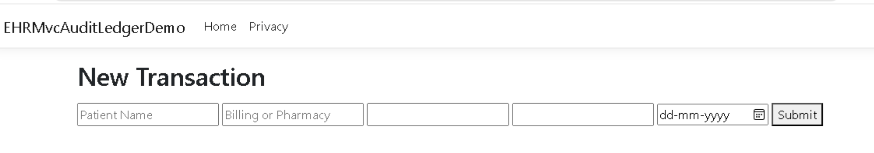

Test 1 - Empty submit (validation check)

Click Submit without filling anything - error messages should appear under each field.

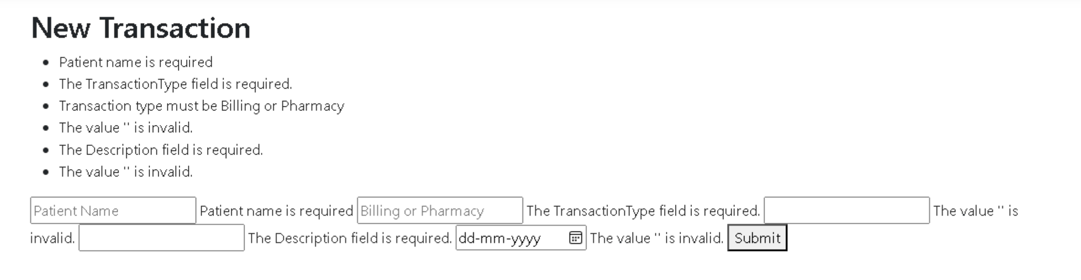

Test 2 - Bad values (custom validation check)
Fill in:
- Patient Name: John
- Transaction Type: Insurance ← wrong on purpose
- Amount: -500 - out of range
- Description: hi - too short
- Date: any past date

Hit Submit - should show custom validation errors for TransactionType and Date.

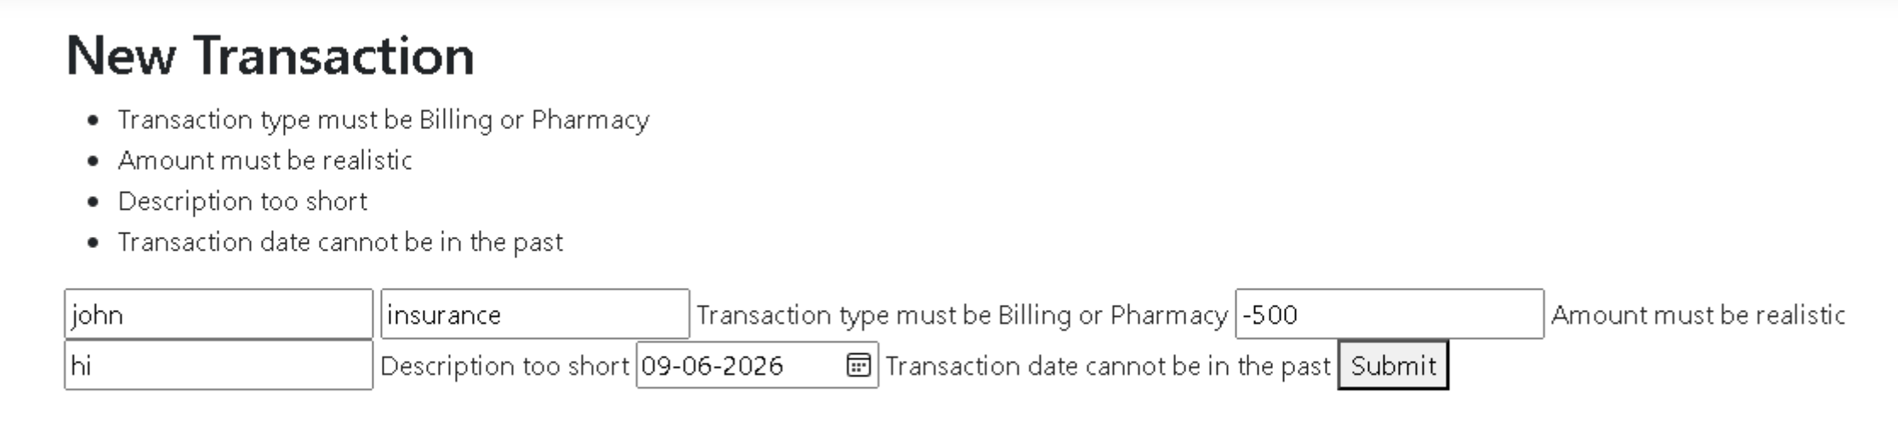

Test 3 - Valid submit (happy path)

Fill correctly:
- Patient Name: John Doe
- Transaction Type: Billing
- Amount: 1500
- Description: Cardiology consultation fee
- Date: tomorrow's date

Hit Submit → should redirect to the ledger/list page showing the saved record.

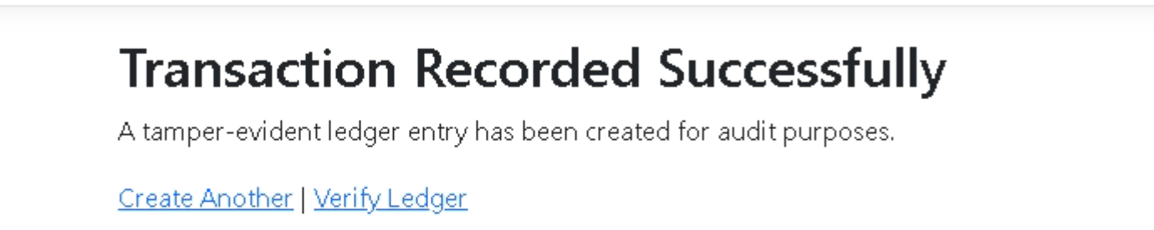

Test 4 - Verify in SQL (after a successful submit)

SELECT * FROM Healthcare.PatientTransactions;

SELECT * FROM Healthcare.TransactionLedger;

You should see 1 row in each table, with CurrentHash and PreviousHash populated in the ledger.

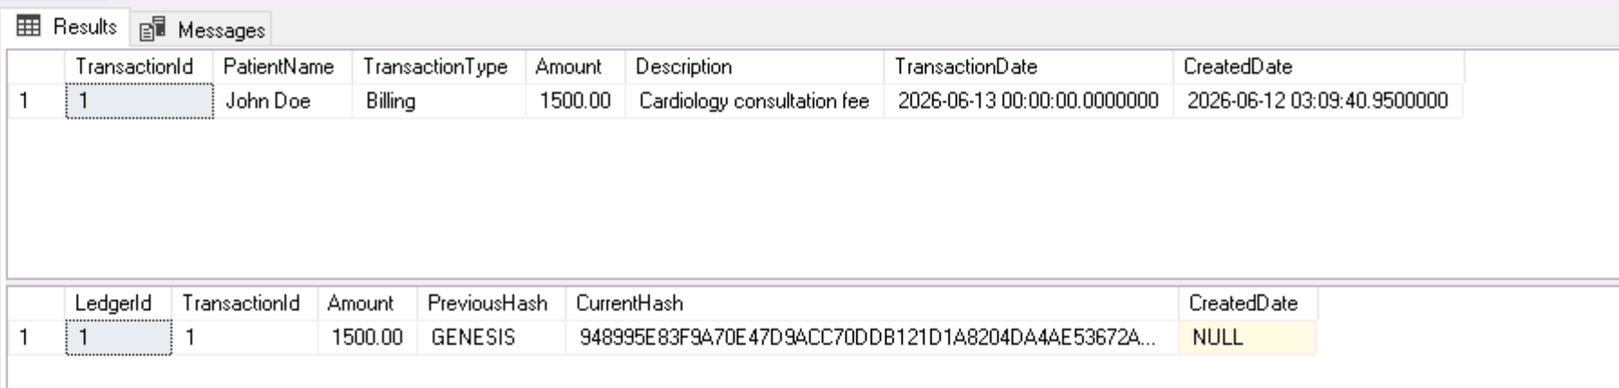

Transaction/Verify

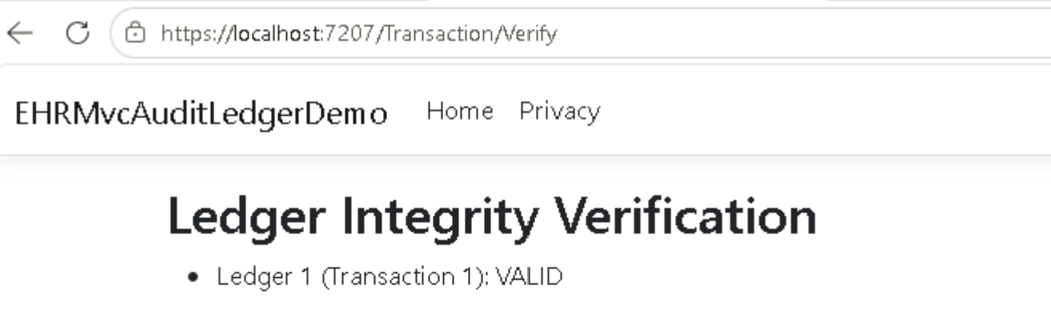

Tamper Test 1 - Modify the operational table (PatientTransactions)

Run this in SSMS:

UPDATE Healthcare.PatientTransactions

SET Amount = 999999

WHERE TransactionId = 1;

Now go back to the browser and hit: /Transaction/Verify

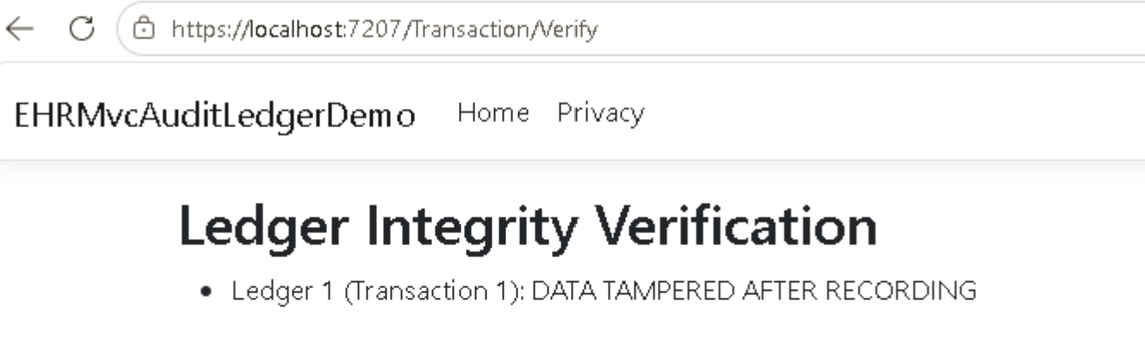
This fires because the controller compares transaction.Amount (999999) vs ledger.Amount (original amount) - they no longer match.

Tamper Test 2 - Modify the ledger itself (TransactionLedger)
First restore Test 1 so it doesn't interfere, then run:

-- Restore original amount first
UPDATE Healthcare.PatientTransactions
SET Amount = 1500.00 -- whatever you originally entered
WHERE TransactionId = 1;



-- Now tamper the ledger
UPDATE Healthcare.TransactionLedger
SET Amount = 888888
WHERE LedgerId = 1;
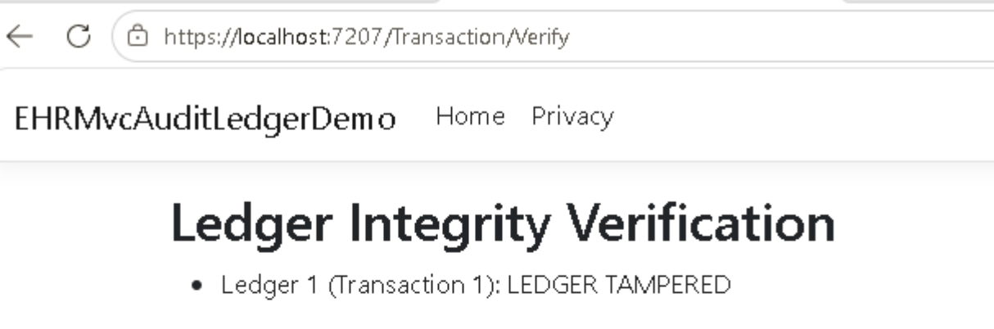
This fires because LedgerHashService.VerifyChain() recomputes the SHA-256 hash using the current ledger amount (888888) and compares it to CurrentHash stored in the DB - the hashes no longer match, so it's flagged as tampered.

Why these are two different statuses:

What you tampered | Status shown
PatientTransactions.Amount | DATA TAMPERED AFTER RECORDING
TransactionLedger.Amount | LEDGER TAMPERED
The system catches both independently - that's the blockchain-style chain detection working exactly as designed.

We didn’t stop the change.
We made change accountable.

